Pebmarsh Parish Council
COVID-19 ALERT
You will all be aware the coronavirus (COVID-19) outbreak. At a time like this Pebmarsh Parish Council encourages you to consider ways to keep yourself, your family and those in our community safe, particularly the isolated and vulnerable. Over the next few months, we may all need some support help and support at different times.
-o-o-o-o-o-o-o-o-o-o-o-o-o-o-o-o-o-o-o-o-o-o-o-o-o-o-o-o-o-o-o-o-o-o-o-o-o-o-o-o-o-o-o-o-
If you can help your neighbours and friends when they are not able to go out – exchange telephone numbers and email addresses now.
-o-o-o-o-o-o-o-o-o-o-o-o-o-o-o-o-o-o-o-o-o-o-o-o-o-o-o-o-o-o-o-o-o-o-o-o-o-o-o-o-o-o-o-o-
If you can help deliver supplies to those self-isolating at home then please let them know. Below you will find a leaflet / card you can print and fill out then post through your neighbour’s door offering your assistance as and when they may need it.
-o-o-o-o-o-o-o-o-o-o-o-o-o-o-o-o-o-o-o-o-o-o-o-o-o-o-o-o-o-o-o-o-o-o-o-o-o-o-o-o-o-o-o-o-
Please let people know if you want to help. Please don’t wait to be asked.
-o-o-o-o-o-o-o-o-o-o-o-o-o-o-o-o-o-o-o-o-o-o-o-o-o-o-o-o-o-o-o-o-o-o-o-o-o-o-o-o-o-o-o-o-
For further information you may find these websites helpful:
https://www.nhs.uk/conditions/coronovirus-covid-19/
https://www.gov.uk/government/organisations/public-health-england
-o-o-o-o-o-o-o-o-o-o-o-o-o-o-o-o-o-o-o-o-o-o-o-o-o-o-o-o-o-o-o-o-o-o-o-o-o-o-o-o-o-o-o-o-
Events are moving very fast, so as all come to terms as to how best to handle the situation inline with their own circumstances, please keep yourselves up to date through the radio, television, internet, family and friends for the latest news and advice.
-o-o-o-o-o-o-o-o-o-o-o-o-o-o-o-o-o-o-o-o-o-o-o-o-o-o-o-o-o-o-o-o-o-o-o-o-o-o-o-o-o-o-o-o-
The Courtyard Stores at Cross End, Pebmarsh is currently well stocked with plenty of provisions and that is the nearest store to replenish provisions or shop for your neighbours.
-o-o-o-o-o-o-o-o-o-o-o-o-o-o-o-o-o-o-o-o-o-o-o-o-o-o-o-o-o-o-o-o-o-o-o-o-o-o-o-o-o-o-o-o-
Please see below for the current, as at 15th March 2020, advice from NHS as well as websites and telephone numbers which may be helpful for you:

Coronavirus (COVID-19)
For health information and advice, read our pages on coronavirus. Learn about the government response to coronavirus on GOV.UK.

Overview- Coronavirus (COVID-19)

Contents
- Overview
- Stay at home advice

COVID-19 is a new illness that can affect your lungs and airways. It's caused by a virus called coronavirus.
These pages are for the public. There is coronavirus information for health professionals on the NHS England website.

Stay at home if you have coronavirus symptoms
Stay at home for 7 days if you have either:
- a high temperature – you feel hot to touch on your chest or back
- a new, continuous cough – this means you've started coughing repeatedly

Do not go to a GP surgery, pharmacy or hospital.
You do not need to contact 111 to tell them you're staying at home.
Testing for coronavirus is not needed if you're staying at home.
Read our advice about staying at home.

Urgent advice: Use the NHS 111 online coronavirus service if:
- you feel you cannot cope with your symptoms at home
- your condition gets worse
- your symptoms do not get better after 7 days

Use the 111 Coronavirus service - Only call 111 if you cannot get help online.

How coronavirus is spread
Because it's a new illness, we do not know exactly how coronavirus spreads from person to person.
Similar viruses are spread in cough droplets.
It's very unlikely it can be spread through things like packages or food.

How to avoid catching or spreading coronavirus

Do
Wash your hands with soap and water often – do this for at least 20 seconds
Always wash your hands when you get home or into work
Use hand sanitiser gel if soap and water are not available
Cover your mouth and nose with a tissue or your sleeve (not your hands) when you cough or sneeze
Put used tissues in the bin immediately and wash your hands afterwards
Try to avoid close contact with people who are unwell

Don't
Do not touch your eyes, nose or mouth if your hands are not clean

Travel advice
There are some countries and areas where there's a higher chance of coming into contact with someone with coronavirus.
If you're planning to travel and are concerned, see advice for travellers on GOV.UK.

Treatment for coronavirus
There is currently no specific treatment for coronavirus.
Antibiotics do not help, as they do not work against viruses.
Treatment aims to relieve the symptoms while your body fights the illness.
You'll need to stay in isolation, away from other people, until you have recovered.

Government response and action plan
- GOV.UK: coronavirus action plan
- GOV.UK: information on coronavirus and the situation in the UK
-o-o-o-o-o-o-o-o-o-o-o-o-o-o-o-o-o-o-o-o-o-o-o-o-o-o-o-o-o-o-o-o-o-o-o-o-o-o-o-o-o-o-o-o-
Please see below for a handy card / leaflet you can print, fill, cut and hand out your neighbours to offer your help.
-o-o-o-o-o-o-o-o-o-o-o-o-o-o-o-o-o-o-o-o-o-o-o-o-o-o-o-o-o-o-o-o-o-o-o-o-o-o-o-o-o-o-o-o-
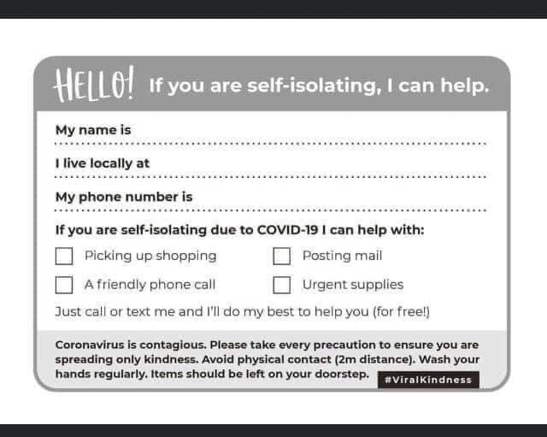

-o-o-o-o-o-o-o-o-o-o-o-o-o-o-o-o-o-o-o-o-o-o-o-o-o-o-o-o-o-o-o-o-o-o-o-o-o-o-o-o-o-o-o-o-
Thank you from Pebmarsh Parish Council to all those able to help others for their community spirit and if you want to speak to someone please do not hesitate to contact anyone of our parish councillors who will be pleased to help as best they can.
Stay safe.
PEBMARSH PARISH COUNCIL
-o-o-o-o-o-o-o-o-o-o-o-o-o-o-o-o-o-o-o-o-o-o-o-o-o-o-o-o-o-o-o-o-o-o-o-o-o-o-o-o-o-o-o-o-

