Pebmarsh, Little Maplestead and Great Maplestead Parish Councils
-0-0-0-0-0- A Joint Parish Council Statement -0-0-0-0-0-
COVID-19 ALERT - UPDATED
You will all be aware the coronavirus (COVID-19) outbreak. At a time like this the parish councils of Pebmarsh, Little Maplestead and Great Maplestead parish councils collectively encourage you to consider ways to keep yourself, your family and those in our communities safe, particularly the self-isolated and vulnerable. Over the next few months, we may all need some support help and support at different times. This situation is very fluid so please keep yourselves up to date through TV, radio, internet, newspapers, friends and family.
-o-o-o-o-o-o-o-o-o-o-o-o-o-o-o-o-o-o-o-o-o-o-o-o-o-o-o-o-o-o-o-o-o-o-o-o-o-o-o-o-o-o-o-o-
If you can help your neighbours and friends when they are not able to go out – exchange telephone numbers and email addresses now. Most of our villages have set up support networks for those self-isolating and the vulnerable groups so please contact your nearest.
-o-o-o-o-o-o-o-o-o-o-o-o-o-o-o-o-o-o-o-o-o-o-o-o-o-o-o-o-o-o-o-o-o-o-o-o-o-o-o-o-o-o-o-o-
If you can help deliver supplies to those self-isolating at home then please let them know and consider volunteering for your local support group. Below you will find a leaflet / card you can print and fill out then post through your neighbour’s door offering your assistance as and when they may need it.
-o-o-o-o-o-o-o-o-o-o-o-o-o-o-o-o-o-o-o-o-o-o-o-o-o-o-o-o-o-o-o-o-o-o-o-o-o-o-o-o-o-o-o-o-
Please let people know if you want to help. Please don’t wait to be asked.
-o-o-o-o-o-o-o-o-o-o-o-o-o-o-o-o-o-o-o-o-o-o-o-o-o-o-o-o-o-o-o-o-o-o-o-o-o-o-o-o-o-o-o-o-
For further information you may find these websites helpful:
https://www.nhs.uk/conditions/coronavirus-covid-19/
https://www.gov.uk/government/organisations/public-health-england
-o-o-o-o-o-o-o-o-o-o-o-o-o-o-o-o-o-o-o-o-o-o-o-o-o-o-o-o-o-o-o-o-o-o-o-o-o-o-o-o-o-o-o-o-
Events are moving very fast, so as all come to terms as to how best to handle the situation inline with their own circumstances, please keep yourselves up to date through the radio, television, internet, family and friends for the latest news and advice.
-o-o-o-o-o-o-o-o-o-o-o-o-o-o-o-o-o-o-o-o-o-o-o-o-o-o-o-o-o-o-o-o-o-o-o-o-o-o-o-o-o-o-o-o-
Your local store and or farm shop are currently well stocked with plenty of provisions and best placed to replenish provisions or shop for your neighbours, some are now offering a delivery service to those self-isolating and or in the vulnerable groups.
-o-o-o-o-o-o-o-o-o-o-o-o-o-o-o-o-o-o-o-o-o-o-o-o-o-o-o-o-o-o-o-o-o-o-o-o-o-o-o-o-o-o-o-o-
Please see below for the current, as at 18th March 2020, advice from NHS as well as websites and telephone numbers which may be helpful for you:

Overview - Coronavirus (COVID-19)

Contents
- Overview
- Stay at home advice
COVID-19 is a new illness that can affect your lungs and airways. It's caused by a virus called coronavirus.

Stay at home if you have coronavirus symptoms
- Stay at home if you have either:
- A high temperature – you feel hot to touch on your chest or back
- A new, continuous cough – this means you've started coughing repeatedly
- Do not go to a GP surgery, pharmacy or hospital.
- You do not need to contact 111 to tell them you're staying at home.
- Testing for coronavirus is not needed if you're staying at home.

How long to stay at home?
- If you have symptoms, stay at home for 7 days
- If you live with other people, they should stay at home for 14 days from the day the first person got symptoms
- If you live with someone who is 70 or over, has a long-term condition, is pregnant or has a weakened immune system, try to find somewhere else for them to stay for 14 days.
- If you have to stay at home together, try to keep away from each other as much as possible.
- Read our advice about staying at home.

Urgent advice: Use the NHS 111 online coronavirus service if:
- You feel you cannot cope with your symptoms at home
- Your condition gets worse
- Your symptoms do not get better after 7 days
- Use the 111 Coronavirus service
- Only call 111 if you cannot get help online.

How to avoid catching and spreading coronavirus (social distancing)
Everyone should do what they can to stop coronavirus spreading.
It is particularly important for people who:
- Are 70 or over
- Have a long-term condition
- Are pregnant
- Have a weakened immune system

Do
- Wash your hands with soap and water often – do this for at least 20 seconds
- Always wash your hands when you get home or into work
- Use hand sanitizer gel if soap and water are not available
- Cover your mouth and nose with a tissue or your sleeve (not your hands) when you cough or sneeze
- Put used tissues in the bin immediately and wash your hands afterwards
- Avoid close contact with people who have symptoms of coronavirus
- Only travel on public transport if you need to
- Work from home, if you can
- Avoid social activities, such as going to pubs, restaurants, theatres and cinemas
- Avoid events with large groups of people
- Use phone, online services, or apps to contact your GP surgery or other NHS service

Don't
- Do not touch your eyes, nose or mouth if your hands are not clean
- Do not have visitors to your home, including friends and family
- The NHS will contact you from Monday 23 March 2020 if you are at particularly high risk of getting seriously ill with coronavirus. You'll be given specific advice about what to do.
- Do not contact your GP or healthcare team at this stage – wait to be contacted.

How coronavirus is spread
- Because it's a new illness, we do not know exactly how coronavirus spreads from person to person.
- Similar viruses are spread in cough droplets.
- It's very unlikely it can be spread through things like packages or food.

Travel advice
There are some countries and areas where there's a higher chance of coming into contact with someone with coronavirus.
If you're planning to travel abroad and are concerned about coronavirus, see advice for travelers on GOV.UK.

Treatment for coronavirus
- There is currently no specific treatment for coronavirus.
- Antibiotics do not help, as they do not work against viruses.
- Treatment aims to relieve the symptoms while your body fights the illness.
- You'll need to stay in isolation, away from other people, until you have recovered.

More information
- GOV.UK: coronavirus action plan
- GOV.UK: information on coronavirus and the situation in the UK
- NHS England: coronavirus for health professionals
- Royal College of Obstetricians and Gynecologists (RCOG): coronavirus advice for pregnant women
-o-o-o-o-o-o-o-o-o-o-o-o-o-o-o-o-o-o-o-o-o-o-o-o-o-o-o-o-o-o-o-o-o-o-o-o-o-o-o-o-o-o-o-o-
Please see below for a handy card / leaflet you can print, fill, cut and hand out your neighbours to offer your help.
-o-o-o-o-o-o-o-o-o-o-o-o-o-o-o-o-o-o-o-o-o-o-o-o-o-o-o-o-o-o-o-o-o-o-o-o-o-o-o-o-o-o-o-o-
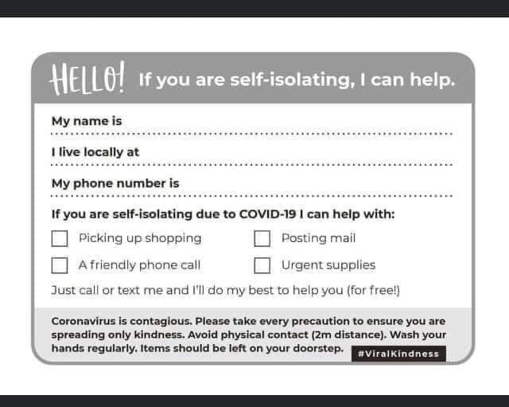

-o-o-o-o-o-o-o-o-o-o-o-o-o-o-o-o-o-o-o-o-o-o-o-o-o-o-o-o-o-o-o-o-o-o-o-o-o-o-o-o-o-o-o-o-
Thank you from all the parish councils to everyone able to help others for their community spirit and if you want to speak to someone please do not hesitate to contact anyone of your parish councillors who will be pleased to help as best they can.
Stay safe.
PEBMARSH, LITTLE MAPLESTEAD AND GREAT MAPLESTEAD PARISH COUNCILS
-o-o-o-o-o-o-o-o-o-o-o-o-o-o-o-o-o-o-o-o-o-o-o-o-o-o-o-o-o-o-o-o-o-o-o-o-o-o-o-o-o-o-o-o-
REF: PKC/COVID19/180320/V1

